We can show command in various ways.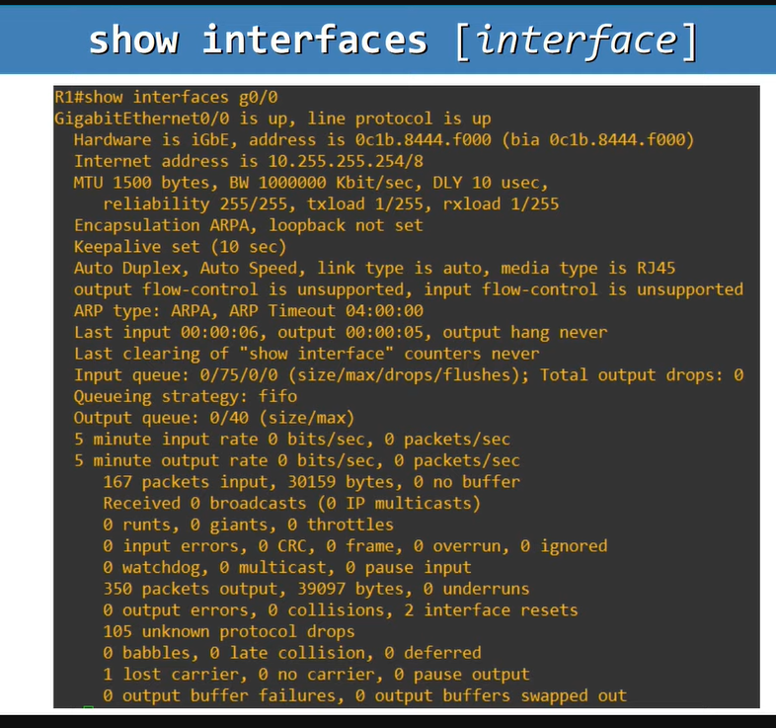

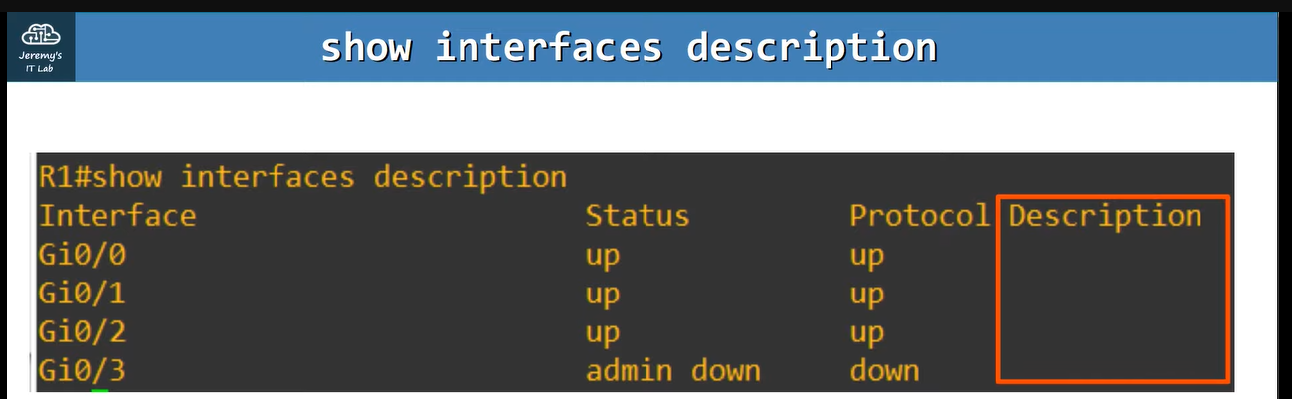

**We can add the descriptions, as you ca see in the following image.**